Presentation 2: The E-R Model

Overview
This presentation provides an overview of the Keys and Relationship. You will introduce to the Attributes, Entity, Relationship and standards of ER Diagram.

Understanding ER
The Entity – Relationship data model perceives the real world as consisting of basic objects called entities and relationships among the objects. The following are the basic features of ER.

- It is a tool to build the logical database design of a System
- It was developed to facilitate database design by allowing specification and represent the overall logical structure of a database.
- It is very useful in mapping the real-world enterprises and usefulness of designing a many database-design tool.
Entity Relationship Diagram
Elements of E-R Diagram
Real-world | E-R-D | Definition | Symbol
Object | Entity | An entity is an any object or activity which an enterprise records
Property | Attribute | instantiated from an object
Relationship | Relationship | Association between two dependent objects
Table 1 : Elements of E-R diagrm

Understanding the Relationship

Entity
Entity is an object in the real world (or even imaginary worlds) about which we want. Or need to maintain information. Persons (e.g.: customers in a business, employees, and authors.

Attributes
Attributes are the significant properties or Characteristics of an entity that Help identify it and provide the information needed to interact with it or use it.

Example 1 :Entity and Attributes in E-R Diagram for Employee Details
First
Middle
Last
Name
Employee
Birth date
Age
SSN
Projects

Relationships
Relationships are the associations between entities they can involve one or more Entities and belong to particular relationship types.
Example 2: Relationship in E-R diagram for Students detail
student1
Rollno1
Assigned

Where Student1 and Rollno 1 are Dependent Entity
Assigned is Relationship

Mapping Cardinalites
Cardinality is a quantity relationship between elements
Mapping cardinalities or cardinality ratio, express the number of entities to which another entity can be associated via a relationship set.
These are explained in detail below.
The following are the different mapping cardinalities
  - One to one
  - One to many
  - Many to one
  - Many to Many
Cardinality is a quantity relationship between elements For example, one-to-one, one-to-many and many-to-one express cardinality.

ONE –TO-ONE RELATIONSHIP
Example 3: Every Employee is assigned to One Workstation
EMPLOYEE
WORKSTATION
Reading the diagram from left to right represent the relationship, every employee is assigned a workstation. Because every employee must have a workstation, the symbol for mandatory existence—in this case the crossbar—is placed next to the WORKSTATION entity. Reading from right to left, the diagram shows that not all workstation are assigned to employees. This condition may reflect that some workstations are kept for spares or for loans. Therefore, we use the symbol for optional existence, the circle, next to EMPLOYEE. The cardinality and existence of a relationship must be derived from the "business rules" of the organization.
For example, if all workstations owned by an organization were assigned to employees, then the circle would be replaced by a crossbar to indicate mandatory existence. One-to-one relationships are rarely seen in "real-world" Data models.

ONE–TO-MANY RELATIONSHIP

Example 4: Department may be assigned Many Projects. But each project will have only One department
DEPARTMENT
PROJECT

Example shows an example of a one-to-many relationship between DEPARTMENT and PROJECT. In this diagram, DEPARTMENT is considered the parent entity while PROJECT is the child. Reading from left to right, the diagram represents departments may be responsible for many projects. The optionally of the relationship reflects the "business rule" that not all departments in the Organization will be responsible for managing projects. Reading from right to left, the diagram tells us that every project must be the responsibility of exactly one department.

Example 5 : Few more examples of Schematic Relationship
Each DEPARTMENT has many LECTURERS, one of whom is head of the DEPARTMENT;
A LECTURER belongs to only one DEPARTMENT;
Each DEPARTMENT offers many different COURSES;
Each COURSE is taught by a single LECTURER;
A STUDENT may enroll for many COURSES offered by different DEPARTMENTS.

MANY-TO- ONE RELATIONSHIP
Example 6: Employees may be assigned too many Projects. Every Project has assigned at least One Employee
EMPLOYEE
PROJECT

MANY-TO- MANY RELATIONSHIP
Example 7: Student can enroll for more than one course. And each course will contain more than one student
STUDENT
COURSE

Example shows a many-to-many relationship between EMPLOYEE and PROJECT. An employee may be assigned too many projects; each project must have many employee Note that the association between EMPLOYEE and PROJECT is optional because, at a given time, an employee may not be assigned to a project. However, the relationship between PROJECT and EMPLOYEE is mandatory because a project must have at least two employees assigned. Many-To-Many relationships can be used in the initial drafting of the model but eventually must be transformed into two one-to-many relationships. The transformation is required because the relational model cannot represent many-to-many relationships.

Example 8 : ER diagram of College DB
DEPARTMENT
C#
Room
LName
DName
Location
Offers
STUDENT
COURSE
LECTURER
Head Of
Is_In
Teaches
Title
Enrolls
S#
SName
M
N
N
M
M
There are 4 entities in this diagram.
- Course
- Department
- Lecturer
- Student
Each entity is related with another with many relationships
Relationships of College DB :
1:1 relationship
between LECTURER & DEPARTMENT;
N:1 relationship
between LECTURER & DEPARTMENT
1:N relationship
between DEPARTMENT & COURSE;
M:N relationship
between STUDENT & COURSE
1:N relationship
between LECTURER & COURSE
1:1 relationship HEAD_OF
between LECTURER & DEPARTMENT;
N:1 relationship IS_IN
between LECTURER & DEPARTMENT
1:N relationship OFFERS
between DEPARTMENT & COURSE;
M:N relationship ENROLLS
between STUDENT & COURSE
1:N relationship TEACHES
between LECTURER & COURSE.

Role of Keys
It plays a vital role in maintaining data accuracy in a Database.
Keys are used to validate the data that is being entered into a database
Keys play a vital role in maintaining data accuracy in a Database
There are Four types of keys
Primary Key
Composite key

Primary keys:
This enforce entity integrity by uniquely identifying entity instances. The primary key of a relational table uniquely identifies each record in the table. It may either be a normal attribute that is guaranteed to be unique (such as Social Security Number in a table with no more than one record per person) or DBMS generated Unique Numbers.
It is Combination of Unique key and not null .Which serves the needs of uniquely identifying each tuple in a relation and to build the relationship with other entity.

Foreign keys:
This provide relationships between tables in the database. In relational, a foreign key in a table is a set of columns that reference the primary key of another table. For each row in the referencing table, the foreign key must match an existing primary key in the referenced table. The enforcement of this constraint is known as Referential Integrity.

Extended Referential Integrity
Normally, a foreign key in one table references the primary key in another table. In some cases, a foreign key may reference the primary key of the same table. This is known as self-referencing keys.

Cross Referencing foreign keys
In a related case, the foreign key of one table may reference the primary key of a second table. The second table also has a foreign key, and it references the primary key of the first table. This is known as cross-referencing foreign keys.
Cross-referencing and self-referencing foreign keys are a special case of Referential Integrity. While not well known, they have many real world uses. For examples, we will use an Employee table containing the fields,
EmpNo, Name, SSN, Salary, DeptNo, MgrNo
The primary key for this table is EmpNo (Employee Number). DeptNo (Department Number) is a foreign key referencing another table - the Department table, which we will describe shortly. MgrNo (Manager Number) is also a foreign key, but it references the Employee table itself, an example of a self-referencing foreign key. The Manager Number in an Employee table row matches the Employee Number of the employee's manager.
The second table is a Department table containing the fields,
DeptNo, Name, Location, MgrNo
DeptNo (Department Number) is the primary key. MgrNo (Manager Number) is a foreign key referencing the Employee table. It identifies the Employee Number of the department manager. The Employee and Department tables are cross-referencing tables. The Employee table has a foreign key referencing the Department table, and the Department tables a foreign key referencing the Employee table.
Self-referencing foreign keys produce a recursive tree structure - like a part explosion. For the Employee table it is an organization chart:
Example 10: Employee Table Organization chart
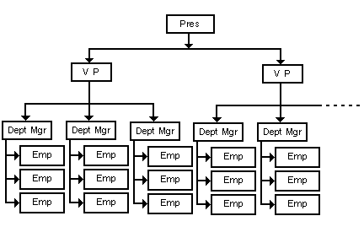

The obvious question here is, who is the manager of the President? You could say the Board of Directors or the stock holders are the managers of the president, but they are often not employees. The Manager Number for the President could be Null (no manager in the organization chart), or it could contain the Employee Number of the President himself - a direct self-reference.
Cross-referencing also produces some interesting lattices. A single department might look like this,

Example 11 : A single department
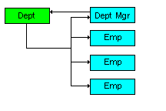
Figure 1: A single department

In other cases, cross-referencing might produce a zigzag chain:
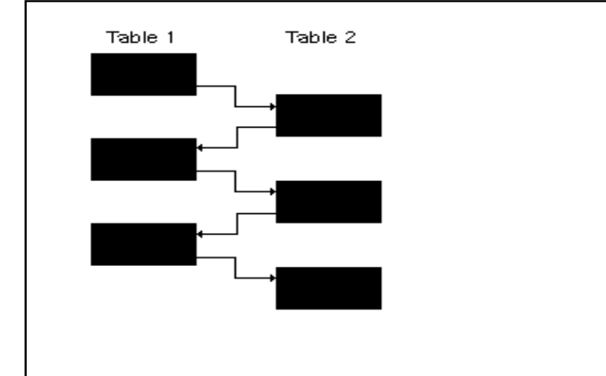
Figure 2: The Structure of Relation between two tables
The structure could also be circular:
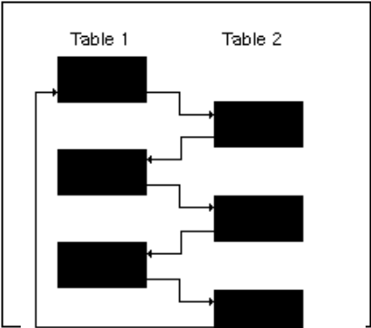
Cross-referencing may also involve more than two tables. Any number of tables may be hooked together in a circular chain of foreign key references.

Composite Key
A key Composed more then one column is called composite key or concatenated Key.
Example 12 : Composite Key
EmpNo | WONO | Start date | End date | Hours single
4561 | AS12 | 12/11/2005 | 12/3/2006 | 150
4562 | AS13 | 12/11/2005 | 12/11/2005 | 8
4563 | AS14 | 13/11/2005 | 13/11/2005 | 8

Primary key (Combination of Emp No. and WONO) Non Key attribute

Key Points

- It helps us to understand the Entity Relationship.
- Role of keys to Maintaining data accuracy in a database
- Understanding the Relationship between entities.

